ANWAR BABY SCHOOL, DAYCARE AND PRIMARY


END OF TERM 1 EXAMINATION 2024
PRIMARY SEVEN MATHEMATICS SET 1
Time Allowed: 2Hrs 30MIN

Name: …………………………………Stream……………………

Read the following instructions carefully:
FOR EXAMINER’S USE ONLY
Qn. No | MARK | SIGN
1 – 10
11 – 20
21 – 22
23 – 24
25 - 26
27- 28
29 - 30
31 – 32
TOTAL

1. The paper has two sections: A and B

2. Section A has 20 short questions (40 marks)

3. Section B has 12 questions (60 marks)

4. Answer ALL questions. All answers to both Sections A

and B must be written in the spaces provided.

5. All answers must be written using a blue or black ball point pen or ink. Diagrams should be drawn in pencil.

6. Unnecessary alteration of work may lead to loss of marks.

7. Any handwriting that cannot be easily read may lead to loss of marks.

8. Do not fill anything in the boxes indicated for Examiner’s

use only.

Turn over
SECTION A: 40 MARKS

1- Divide: 2 2 4

2- Write 101,011 in words

………………………………………………………………………………………………………………

……………………………………………………………………………………………………………..

3- Simplify: +7 - -3

4- Find the square of the next number in the sequence

2, 3, 5, 7,

5- Shade either set P or set Q in the Venn diagram below.

P Q

6- Workout: 3 + 1
5 4

7- Workout: 3 + 5 = (finite 7)

8- Simplify: 4y – 5x + y + 2x

9- Add: 3.07 + 4.4

10- How many hours are in 150 minutes?

11- Using a pair of compasses, a ruler and a sharp pencil, construct an angle of 1200

12- The cost of 3 books is sh. 1800. How many books will one buy with sh. 4200?

13- Given that represent 12 mangoes. How many pictures will represent 20 mangoes?


14- Convert 110two to decimal base.

15- Write the afternoon time shown on the clock face below in 24 hour clock system

16- The mean of 2, 4, 0 and k is 3. Find the value of k.

17- Annet spends sh. 120,000 on food and this is two thirds of her salary. Calculate her salary.

18- The square root of a number is 9. Find the number.

19- Teacher Robert was the 7th from either side of a line of pupils. How many pupils were in the line?

20- Calculate the area of the figure below.

5cm

8cm
SECTION B :60 MARKS

21- In a class of 54 pupils, 30 pupils like mathematics (M), 23 pupils like English (E), y pupils like both English and mathematics, 6 like neither of the two.
(a)Represent the above information on a venn diagram below. (02marks)
n( ) = 54
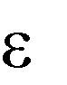

n(M)=30 n(E) = 23

y

6

(b)How many pupils like both mathematics and English? (02marks)

(c) How many pupils like only one subject? (01mark)

22- Use the number line below and answer the questions that follow. q
p

-7 -6 -5 -4 -3 -2 -1 0 1 2 3 4 5 6 7 8 r
(a) Name the integers represented by the arrows. (01mark@)

r =

p =_

q =_

(b) Write the mathematical sentence for the number line above (02marks)

23- A shopkeeper bought 5 boxes of soap each containing 30 bars. He bought each box at sh. 100,000. Calculate the percentage profit he made on all the 5 boxes of soap if he sold each bar at sh. 4000 (05marks)

24- The sum of three consecutive even numbers is 24. If the largest number is h, find the numbers. (05marks)
25- Find the value of the unknowns in the diagrams below.
(a) (02marks)

1200 2m

(b) (02marks)
h

400

26- Akello, Betty and Cissy shared sh.12, 000 in a ratio of 2:3:5 respectively. (a) How much did each get? (04marks)

(b) How much more did Cissy get than Akello? (02marks)
27- Two bells in a school ring at intervals of 40 minutes and 30 minutes for upper and lower primary respectively.
(a) After how long do the two bells ring together? (03mark)

(b) If they ring at 11:00am, when will they ring together again? (02marks)

28- Use the Venn diagram below to answer the questions that follow.
Fx F18

22 21
w
23 31

(a)Find the value of : (02marks@) (i) w

(ii) x
(b) Calculate the L.C.M of Fx and F18 (02marks)

29- Maama Joan had a twenty thousand shilling note. She bought the following items from the quick supermarket.
4 litres of milk at sh. 6000
2 ½ kg of maize flour at sh. 2400 a kg
500gm of curry powder at sh. 1000 per kg
2 bars of soap at sh. 2000 a bar.
(a) How much did she spend altogether? (04marks)

(b) What was her change? (01mark)

30- Solve for m: m = 12 (02marks)

(b) Given that a = b =4 and c = -2. Evaluate ab (02marks)
c
31- Use the triangle below and answer the questions that follow.
C

8m 13m

A 4m D 6m B
(a) Calculate the area of the triangle ADC (02marks)

(b) Calculate the perimeter of the triangle ABC (02marks)
32- On the grid below, plot the following coordinates.
(a) A(-2, -3) , B (-2, 0) , C(1, 3) and D (+1 , -3) (04marks)
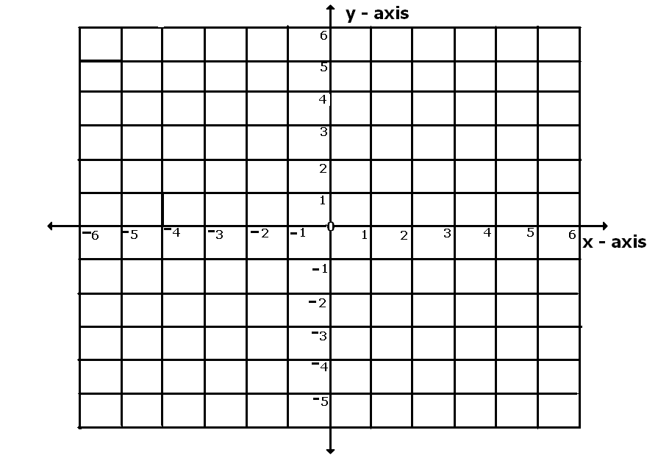

(b) Join coordinates A to B, B to C, C to D and D to A (01mark)

(c) Name the figure formed. (01mark)

**END** JULIUS

